**Analysis Conclusions**

The final KNIME workflow is shown below:

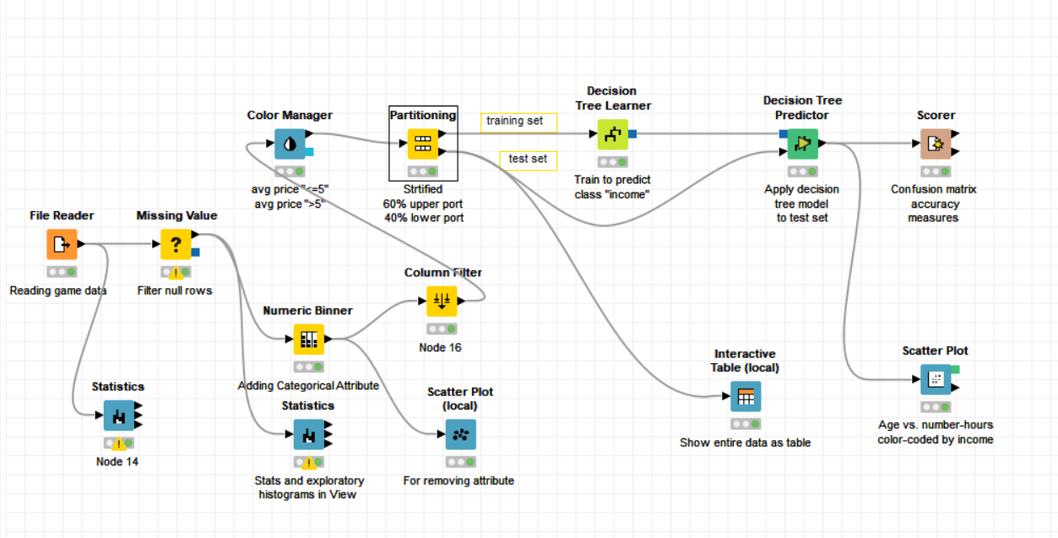

What makes a HighRoller vs. a PennyPincher?

* User playing on Iphone are generally HighRoller
* User playing on other platform are generally PennyPincher

|  |
| --- |
| **Specific Recommendations to Increase Revenue** |
| 1. Most of the Iphone (86%) and of Mac(33%) user are Highroller, If we offer more promotion and ads to mac user, they are more likely to spend more money. Also future product can be made for Apple users to increase revelnue. |
| 2. 35% of total users are android user. As android user hold majority of market, specific ads and promotion packages can be offered to make them spend more and increase the overall revenue. |